Traditional Chinese Medicine at Tong Keow Healthcare
  - Localisation everyday care and pattern differentiation
GEC1044 Group Fieldwork Report • Revised complete draft
TD3 Group 2
Lou Yu Luke · Chang Tze Yi Othniel · Li Xudong
Curtis Chang Kai Xian · Hu Zhixuan Shirley
Tutor Lin Shi Ting
Field visit 13 September 2026
Block 809 Hougang Central #01-170 Singapore 530809
Revised 4 October 2026

Revision note
This revision retains the presentation’s fieldwork findings within the thematic analysis of everyday care, convenience and localisation. It distinguishes evidence from interpretation and treats industry examples as promotional or journalistic rather than peer-reviewed studies. The analysis now tests retail associations against contrasting ginseng profiles, separates cultural contact from shared therapeutic understanding, and connects access mechanisms to the chain and neighbourhood context. Chinese typography, explicit appendix numbering, illustrated five-column tables and APA 7 references are retained. The group presentation and Google Doc template are unchanged.

1 Introduction
Tong Keow’s Hougang outlet provides a small-scale case of continuity through adaptation in Traditional Chinese Medicine (TCM). Our field photographs show medicinal materials and packaged soups within a shop selling everyday foods. The staff member described nourishment, throat comfort, fatigue and lifestyle concerns as reasons for purchasing herbs and prepared products. This is our interpretation: TCM becomes usable through familiar meals, selected ingredients and convenient formats that change how consumers encounter traditional knowledge. These adaptations help explain access to TCM without establishing the effectiveness of any treatment or the beliefs of individual customers.
The report asks how that accessibility is produced. Everyday food therapy places herbs within household routines; convenience changes the work needed to select and prepare them; and localisation concerns retail organisation, processing, packaging and cultural contact. These themes deepen the presentation’s account of preventive care, generational differences and local adaptation. The detailed survey record is preserved in Appendix A so that the analysis can follow the relationships among findings rather than the order of questionnaire requirements.
Our critical concept is pattern differentiation and treatment according to the identified pattern 辨证论治. Retail language can associate fatigue with a tonic or a cold with a familiar remedy, but an individual treatment decision requires assessment of the person’s configuration of signs and symptoms. The same format can therefore widen access while simplifying the reasoning through which a remedy is selected. We investigate that tension without presenting this retail visit as an observed clinical consultation.

2 Fieldwork method and the neighbourhood medicine hall

2.1 Sources and levels of evidence
We observed the shop, photographed displays and conducted a semi-structured interview with one staff member on 13 September 2026. The group presentation organises the fieldwork record; the interview transcripts, presentation script and photographs are used to check its claims. Because the transcripts contain recognition errors, we paraphrase clear statements rather than invent exact quotations. References to “the staff member” below refer to this interview (Tong Keow staff member, personal communication, September 13, 2026). Reports about other TCM institutions provide structural comparison only and are not evidence of our own patient encounters.
Staff reports document the interviewee’s descriptions of demand, clientele and sourcing. Direct observations identify what photographs and displays visibly show. Our interpretations connect those findings to course concepts; they are marked explicitly. Secondary evidence is cited where it establishes historical, demographic, regulatory or industry context. We obtained no numerical sales records, customer survey, clinical case notes or supply-chain documentation. “Commonly sold” and “popular” retain the presentation’s terminology but do not mean a verified twelve-month sales ranking.

2.2 Tong Keow history and its mixed retail model
The presentation dates the original Toa Payoh shop to 1968; a directory’s account of its fiftieth anniversary in 2018 supports that reported heritage. ACRA records distinguish Tong Keow Medicine and Provision Shop, registered on 29 March 1975, from Tong Keow Medical Hall Pte. Ltd., incorporated on 1 January 2015; succession between them was not documented. Both list 70 Lorong 4 Toa Payoh #01-333, Toa Payoh Vista, as their registered address. Their primary and secondary activity codes, 47723 and 47102, correspond to Chinese medicine shops and mini-marts, convenience stores and provision shops. These records support a mixed retail classification, not a verified headquarters or warehouse (Accounting and Corporate Regulatory Authority [ACRA], n.d.; Healthcare.com.sg, n.d.; Singapore Department of Statistics [DOS], n.d.).
The tutor identifies Tong Keow as a chain, and the directory links its Toa Payoh and Hougang outlets. The photographs directly show herbs, soup packs, grains and other foods, including Tong Keow branding. This is our interpretation: the mixed retail model places medicinal and culinary shopping within one neighbourhood business, while the chain format raises the possibility of shared purchasing and product presentation. We did not compare branches, interview management or inspect purchasing records. Common branding establishes visual identity; shared procurement and central assembly remain unverified explanations for the Hougang shelves.

2.3 Hougang context and the reported customer base
The staff member described the clientele as mainly Chinese, middle-aged and older, including people in their forties and fifties. Official neighbourhood figures provide a context for that impression, with different geographical units kept separate. Hougang planning area had 228,140 residents in June 2024. HDB reported 57,557 dwelling units managed in Hougang and 165,450 residents housed in its flats as at 31 March 2024. The planning-area total includes other housing and is not interchangeable with the HDB-town figure (DOS, 2024; Housing & Development Board [HDB], 2024, pp. 11–12).
In the official June 2025 table, Hougang Central subzone has 4,620 residents. Using official rounded age-band totals, approximately 1,070 residents are aged 65 or above, or about 23% of the population. The figures are rounded to the nearest ten; the subzone provides neighbourhood context rather than a measured catchment for the shop (DOS, 2025).
An older-adult study offers a separate view of established neighbourhood life. Among 647 Hougang respondents, 17% lived alone, compared with 15% among 552 respondents in Taman Jurong; the difference was not statistically significant. The Hougang respondents had an average age of 69 and residential tenure of 22 years. These are sample characteristics, not evidence that 17% of Singapore’s solitary older residents live in Hougang or that solitary living causes medicine-hall purchases (Chua et al., 2025). This is our interpretation: long residence and repeated use of local amenities provide a plausible setting for familiar neighbourhood retail relationships, although the study did not measure purchases at Tong Keow.
NHB’s history of Tou Mu Kung records a Teochew community in Hougang associated with fishing, farming and rubber cultivation (National Heritage Board [NHB], n.d.). This supplies historical context for the presentation’s discussion of Chinese medicine within local community life. It does not establish the dialect identity of current customers. This is our interpretation: established housing, a substantial older population and Chinese community history make the staff’s account contextually intelligible. They cannot demonstrate causation, determine consumer preferences by ethnicity or show that every visitor lives nearby. The reported forty- and fifty-year-old clientele also cannot be equated with the demographic category aged 65 and over.

3 Everyday care and food therapy

3.1 Medicinal materials within household nourishment
The presentation’s eight common-herb entries are ginseng/American ginseng, Dang Shen, Huang Qi, Yu Zhu, Huai Shan, red dates, goji and monk fruit. Table A1 retains these entries while separating the two ginseng materials into distinct reference profiles. The staff member described Dang Shen, Huang Qi, Yu Zhu, Huai Shan, red dates and goji as common soup ingredients. This is evidence of their reported use in cooking, not a complete prescription. The photographs show prepared ingredient packs and a family cooking image on the soup display (Figures 1–2). They corroborate a domestic food setting without establishing how often households cook or consume these preparations.
This is our interpretation: the overlap between herbs and familiar foods gives medicinal vocabulary an ordinary setting. Nourishing life 养生 concerns everyday maintenance, while the idea of medicine and food sharing a source 药食同源 helps describe the movement of materials between nourishment and treatment. An ingredient does not automatically perform the same role in every preparation. Lim et al.’s (2005) earlier survey of complementary and alternative medicine in multiracial Singapore provides evidence that health maintenance was a significant use context; it does not supply present-day sales or customer data for our outlet. Yang’s (2022) history similarly places Chinese medicine within changing community and institutional arrangements. These sources contextualise the field account rather than verify its product claims.

3.2 Soup packs and the meanings of light replenishment
The presentation names Qing Bu Liang 清补凉, Dang Shen–Huang Qi soup 党参北芪补气汤, Yu Zhu–Huai Shan soup 玉竹淮山润燥汤, goji–red date soup 枸杞红枣养生汤 and Five Finger Fig soup 五指毛桃健脾汤. Table A4 preserves all five and distinguishes named ingredients from unknown complete recipes. The interview supplied an ingredient list rather than five fully documented formulas; the photographs do not independently confirm every presentation label. This qualification keeps the written report aligned with the slides while making the evidential status of their synthesis explicit.
The staff member and presentation associated these soups with maintenance, digestion, moistening and light replenishment 清补, rather than intensive tonification 大补. This is our interpretation: such positioning makes replenishment compatible with ordinary meals, without requiring consumers to describe themselves as patients. The Five Phases association of Earth with the Spleen helps explain traditional digestive-support language; Wood and the Liver help contextualise the mood-related language discussed later. These refer to TCM functional relations, not direct equivalents of biomedical organs (World Health Organization [WHO], 2022). Soup labels and functional vocabulary describe intended use; they do not demonstrate a diagnosed pattern, a recovery outcome or a clinically appropriate dose.

3.3 Climate as a retail explanation rather than a diagnosis
The staff member linked monk fruit’s popularity and lighter soups to Singapore’s environment. MSS describes an equatorial climate with high temperatures, abundant rainfall and high humidity throughout the year, with monsoon and inter-monsoon periods (Meteorological Service Singapore [MSS], n.d.). That is an independently documented climatic background. It does not independently verify the staff’s explanation of sales. The phrase “without four distinct seasons” in the presentation is therefore treated as a broad description of tropical conditions rather than a claim that Singapore lacks seasonal weather variation.
The course reading of the Suwen relates seasonal conduct to the maintenance of health (Unschuld & Tessenow, 2011, pp. 45–57). This is our interpretation: the staff’s account shows environmental reasoning being adapted from a seasonal vocabulary to an equatorial retail setting. It remains a situated interpretation. High ambient heat does not mean every individual has a heat pattern; high humidity does not establish dampness in every body. Yu Zhu’s moistening association is not synonymous with eliminating dampness.
辨证论治 requires the person’s signs and circumstances to justify selection, so climatic context cannot substitute for individual assessment.

4 Convenience and changing consumption forms

4.1 Generational accounts and redistributed preparation
The staff member described younger customers as buying fewer raw herbs and preferring teas, supplements and simpler preparations. The eight categories in Table A2 retain exactly the presentation’s list: ginseng tonics, monk-fruit products, flower/herbal teas, soup packs, Lingzhi supplements, liver-care/mood-support products, Yin Qiao-type remedies and medicated oils. We did not interview consumers or measure purchases by age. The generational account is therefore staff testimony about this outlet, not evidence that all young Singaporeans have the same preference or have abandoned traditional medicine.
The photographs show preselected dried packs, packaged goods and a multi-buy promotion. Selection and portioning have already been performed for the buyer, but the photographed soups still require cooking. This is our interpretation: convenience redistributes effort rather than necessarily eliminating it. A packer selects the combination, staff explain its purpose and a household completes preparation. A ready-to-drink tea would shift brewing to the seller, whereas a capsule changes both preparation and consumption. We did not confirm a ready-to-drink range at Tong Keow. This distinction develops the slides’ convenience argument without adding an unobserved product to the field inventory.

4.2 Comparative industry examples
These comparative industry examples are promotional or journalistic accounts, not peer-reviewed studies. NYP describes Heng Foh Tong’s redesign of herbal drinks for millennials (Nanyang Polytechnic [NYP], n.d.). Amacha markets TCM-inspired milk teas; a founder interview claims over 150,000 cups sold in eight months, without audited or age-disaggregated data (Amacha, n.d.; Angelynn T., 2026). Teck Soon’s owner reported a 30% sales increase after replacing drawer storage with storefront herb displays in 1982 (Chin, 2024). Eu Yan Sang’s halal category illustrates dietary accessibility, not Tong Keow certification (Eu Yan Sang, n.d.). What these accounts do document is that businesses deliberately redesign formats and presentation to change how customers encounter herbal goods. This is our interpretation: that documented strategy makes the presentation’s convenience theme analytically plausible; national youth preferences and its effect on Tong Keow purchases remain unmeasured.

4.3 Lifestyle language and what lower demand reveals
The staff member associated late nights, long work hours, stress and prolonged phone use with liver-care or mood-support preparations. This is our interpretation: wellness marketing can turn a diffuse lifestyle concern into a familiar product choice, linking the presentation’s account of pressure to its account of convenient forms. We did not verify causal links or diagnose customers. The photograph identifies a Nature’s Green example; its connection to the staff’s exact preparation remains unconfirmed. 疏肝解郁 describes soothing Liver-related constraint in a TCM vocabulary; it does not itself establish depression treatment or a biomedical hepatic disorder.
National labour data also qualify a simple story of ever-increasing work intensity. MOM reported average usual weekly working hours of 41.4 among employed residents in 2025, down from 44.2 a decade earlier (Ministry of Manpower [MOM], 2026). An average does not describe each customer’s schedule or stress. It provides context while preventing us from turning staff accounts of pressure into an unsupported claim that national working hours are continually rising. Preparation effort, work routines and product use would need to be studied together through customer interviews before this suggested relationship could be tested.
The presentation’s low-demand examples are Ban Zhi Lian 半枝莲, specialist herbs requiring combinations and strong tonic formulas 大补方. Table A5 retains one named material and two categories, rather than inventing three ranked herbs. The staff member linked lower appeal to unfamiliarity, preparation and the need for guidance; the presentation also linked strong tonics to climatic suitability. This is our interpretation: reduced demand for a more demanding format need not imply rejection of TCM as a whole. The staff also described stocking less of poorly selling items, so observed availability is partly selected by the retailer and cannot independently validate a bottom-three ranking.

5 Localisation through processing packaging and cultural contact

5.1 Separating cultivation manufacture and retail selection
The staff member described raw materials as coming mainly from China, citing variety and cost, and described limited local cultivation. Cactus 仙人掌, roselle 洛神花, patent medicines 中成药, Five Flower Tea 五花茶 and monk-fruit tea 罗汉果茶 remain the five locally linked examples in Table A3. They were not verified as five Singapore-grown or Singapore-manufactured items. Staff described a Singapore-made preparation without naming it. The supplied Nature’s Green Mind Soothe Capsules photograph shows a “Made in Singapore” label, without independently verifying manufacture. Statements about climatic limits on cultivation and the relative cost of Chinese supply remain the interviewee’s explanations, not an agronomic or price comparison conducted by the group.
The photographs show Tong Keow branding, selected soup materials and geographical labels on the cabinet. This is our interpretation: localisation can occur at several stages, including assembling ingredients into a familiar soup, portioning, naming and presenting them for local use. Visible branding supports retail adaptation. It does not establish the place where a specific ingredient was grown or a pack was assembled. This distinction refines the presentation’s statement that imported materials are processed and packaged locally: that account is retained as staff-reported, while product-level local processing remains unverified.
Singapore’s Chinese Proprietary Medicines (CPM) framework establishes that local manufacture and assembly are formal regulated activities. HSA’s dealer guidance requires the relevant licences for importing and wholesale supply, and a valid manufacturer’s licence and GMP compliance for local manufacturing or assembly facilities. Its consumer guidance includes re-packers among regulated dealers and requires product listing before a CPM is imported, manufactured or sold (Health Sciences Authority [HSA], 2026c, 2026d). These obligations concern finished Chinese Proprietary Medicines and the activities performed by a dealer. They do not automatically classify every raw herb, food, tea or soup pack as a CPM, or prove that Tong Keow operates a licensed assembly facility. We did not audit its licences or identified products.

5.2 Packaging as regulatory and cultural translation
HSA’s CPM listing guidelines require full labelling in English and allow additional languages, whose text must correspond to the English information. Required particulars include product and ingredient information, batch and expiry details, with relevant manufacturer, importer or assembler details on outer packaging (HSA, 2025, section 5). These requirements show how a finished medicinal product must become legible within Singapore’s regulatory setting. Listing is not evidence that its therapeutic effects have been proven (HSA, 2026b). The photographs of Tong Keow packs establish branding and packaged form, but our images and records are insufficient for a complete bilingual label or compliance audit.
A packaging study provides a regional comparison rather than Singapore-specific field evidence. Liu et al. (2026) examined Chinese herbal medicines sold in Malaysia and showed how legal constraints shape translated product names and therapeutic statements. Their account helps frame translation as a negotiation between medical vocabulary, permissible claims and consumer communication. Malaysia’s rules and sampled products cannot substitute for HSA requirements or evidence about Tong Keow’s labels. This is our interpretation: packaging can alter how inherited knowledge is encountered, but changes in language, dosage form or branding alone do not establish that a customer understands the underlying pattern logic.
Quality language also affects that encounter. The staff member emphasised fresh colour, visible freshness and sulphur-free materials. Figure 3 shows the sulphur-free Dang Shen claim and separate American ginseng label. It verifies the presence of the claims rather than production methods, authenticity or safety. HSA’s supplement-claims guidance rejects the implication that natural origin guarantees safety (HSA, 2026a). This is our interpretation: reassuring labels can support retail trust, but neither a quality claim nor convenient packaging resolves individual suitability under 辨证论治.

5.3 A shared shopping space and differing meanings of use
The staff member described Malay customers buying dessert ingredients and Indian customers buying nuts, alongside a largely Chinese clientele. We did not independently identify customers’ ethnicity or ask them about medical beliefs. The photographs show a product mix compatible with culinary shopping, but cannot verify the reported purchasing pattern. This is our interpretation: the medicine hall’s combined food and medicinal range offers reasons for contact across cultural boundaries. Buying a dessert ingredient in this space does not show acceptance of Qi, meridians or pattern differentiation.
This is our interpretation: a shared retail space can support everyday contact without requiring shared therapeutic interpretation. Here cultural adaptation concerns the range of uses attached to the medicine hall: a culinary purchase can coexist with a wellness purchase while drawing on different meanings. Cultural accessibility may therefore expand through overlapping routines rather than agreement about Qi or meridians. The reported purchases identify routes into that shared space; they do not demonstrate interaction between customers or a historical shift in their beliefs.

6 Pattern differentiation and continuity through adaptation

6.1 Retail associations and the assessment they cannot replace
WHO defines the four examinations 望闻问切 as inspection, listening and smelling, inquiry and palpation; the findings inform pattern differentiation and treatment selection (WHO, 2022). This is our interpretation: the essential distinction is between recognising a complaint and assessing its configuration within an individual. Table A6 records retail associations, without an observed examination, justified pattern, dose or treatment duration. Those associations cannot substitute for clinical assessment or establish that 辨证论治 occurred.
The staff’s fatigue pairing with ginseng or Dang Shen in Table A6 illustrates the gap. The presentation groups ginseng and American ginseng, but Table A1 distinguishes the former’s neutral nature from the latter’s cool nature and Yin-nourishing functions (The Hong Kong Polytechnic University [PolyU], n.d.-a, n.d.-h). This is our interpretation: fatigue alone identifies neither the relevant pattern nor which profile, if either, suits a person.
This is our interpretation: format does not determine individualisation. A prepared product can follow clinical assessment, and raw herbs can be bought without one; climate supplies context rather than an individual diagnosis. The decisive evidence is a documented connection between assessed signs and treatment selection, which this visit did not provide.

6.2 Connecting everyday routines formats and local institutions
This is our interpretation: everyday care, convenience and localisation form connected mechanisms of access. Food use supplies the household setting; preselected packs reduce ingredient-selection work while retaining cooking; local branding and product information present materials in recognisable forms. The mechanisms reinforce one another: familiar use gives selection a purpose, while packaging carries that intended use into the shop and home. Adaptation also redistributes expertise among producers, staff, household cooks, consumers and, where involved, clinicians. None of these mechanisms alone establishes that consumers understand the pattern logic behind a product or receive individually appropriate treatment.
Sections 2.2–2.3 make the setting part of the explanation. The mixed business classification and branded display connect medicinal–culinary retail to Tong Keow’s organisational identity. Hougang’s established housing and older population, with long residence in the study sample, contextualise the staff-described clientele. This is our interpretation: branding links the branch to a wider business, while household food and wellness routines give the model a neighbourhood setting. These conditions help explain its local fit; shared procurement, repeat purchasing and their causal weights remain unmeasured.
This account follows Unschuld’s (2018) emphasis on selection and adaptation and Yang’s (2022) history of Singapore’s community and professional institutions. This is our interpretation: the medicine hall adds a retail mechanism to that history. 辨证论治 provides the critical distinction between making inherited knowledge accessible and documenting an individually justified treatment decision.

7 Limitations and remaining evidence gaps
This study covers one visit, one staff interview and one outlet. Common-seller and lower-demand lists are unranked reports, without sales totals or a verified twelve-month period; customer age, ethnicity and motives were not measured. Neighbourhood figures use different geographical boundaries, and the older-adult study concerns a sample rather than the shop’s catchment. Promotional and journalistic industry examples demonstrate particular strategies, not causal effects, national preferences or Tong Keow customer behaviour. They are contextual comparisons, distinct from academic research and official statistics.
Item-level sourcing, complete soup recipes and chain purchasing arrangements remain unverified. The supplementary photograph identifies a Nature’s Green product labelled “Made in Singapore”, but does not establish its factory, complete formula or whether it was the exact preparation intended in the interview. The presentation’s 1968 heritage account is distinguished from registration dates, and climatic explanations are not individual diagnoses. An in-house physician was not clearly confirmed: physician availability and the clinical survey requirements remain not established, rather than evidence of absence. MOH describes professional registration, but the interview establishes neither the staff member’s credentials nor an assessed clinical encounter (Ministry of Health [MOH], 2026). Follow-up would require product labels, sourcing records, branch comparisons, customer data and documented consultations.
MOH reported that nearly 40% of TCM users in the 2022 National Population Health Survey combined TCM and Western medicine for the same condition (MOH, 2025). This contextual figure does not establish our customers’ treatment choices or motivations. External reference images in Tables A1, A2 and A5 add no observed stock; neither those images nor the field photographs establish therapeutic efficacy, regulatory compliance, botanical authenticity or a community’s medical beliefs.

8 Conclusion
At Tong Keow, TCM is made usable through household nourishment, redistributed preparation and a neighbourhood shop that combines medicinal and culinary retail. The fieldwork’s herbs, soups, product categories and staff accounts show the concrete settings through which people encounter it; the thematic analysis connects those settings rather than treating the survey as a sequence of answers.
This is our interpretation: continuity is sustained through adapting ways of access and settings of use, rather than preserving raw-material forms alone. Yet adaptation is not 辨证论治. Retail associations make products intelligible, while an individual treatment decision requires assessed signs and justified selection. The report’s central contribution is to explain how TCM becomes usable while keeping that clinical distinction visible.

Appendix A Detailed fieldwork evidence
These records preserve the presentation’s substantive inventory. A1–A5 correspond to former Sections 3.1–3.5; the questionnaire sequence is retained here for checking completeness, while Sections 3–5 supply the thematic analysis. Traditional applications are reference information or reported positioning, not evidence of clinical efficacy.

A1 Eight herb entries with separate reference profiles
The presentation groups ginseng and American ginseng in one entry. Nine reference rows therefore represent eight reported entries, not a ninth seller or an annual ranking. The field cabinet independently labels American ginseng.
Table A1 Traditional herb profiles in the eight presentation entries
Herb | Nature & Flavour | Meridian | Function | Application
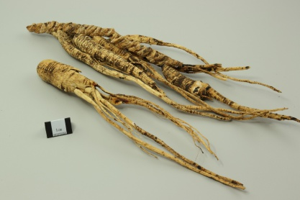  人参 Ren Shen  Ginseng (root)  (PolyU, n.d.-h) | Sweet, slightly bitter; neutral | Heart, Spleen, Lung | Strongly tonifies original Qi; supports Spleen and Lung; generates fluids; calms the spirit. | Poor appetite, fatigue and breathlessness in Qi-deficiency patterns; thirst from fluid depletion.
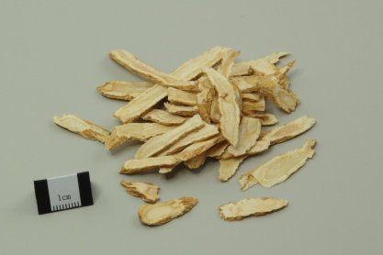  西洋参 Xi Yang Shen  American ginseng (root)  (PolyU, n.d.-a) | Sweet, slightly bitter; cool | Heart, Lung, Kidney | Tonifies Qi and nourishes Yin; clears heat; generates fluids. | Fatigue, dry mouth, thirst and cough in Qi–Yin deficiency with deficiency heat.
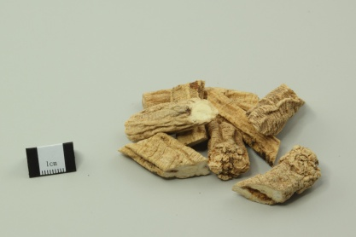  党参 Dang Shen  Codonopsis (root)  (PolyU, n.d.-m) | Sweet; neutral | Spleen, Lung | Tonifies middle Qi; strengthens Spleen and Lung functions. | Poor appetite, loose stools, fatigue and shortness of breath in Spleen–Lung Qi deficiency.
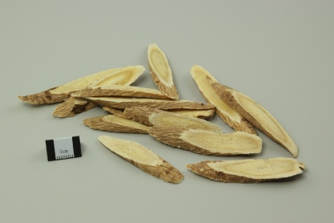  黄芪 Huang Qi  Astragalus / milkvetch (root)  (PolyU, n.d.-l) | Sweet; warm | Spleen, Lung | Tonifies Qi; strengthens exterior defence; promotes fluid discharge and tissue repair. | Fatigue, poor appetite and loose stools in Qi deficiency; spontaneous sweating from weak exterior defence.
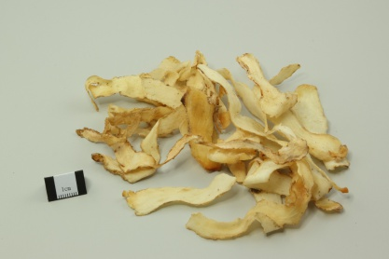  玉竹 Yu Zhu  Fragrant Solomon’s seal (rhizome)  (PolyU, n.d.-g) | Sweet; slightly cold | Lung, Stomach | Nourishes Yin; moistens dryness; generates fluids and relieves thirst. | Dry cough, dry throat and thirst in Lung–Stomach Yin deficiency.
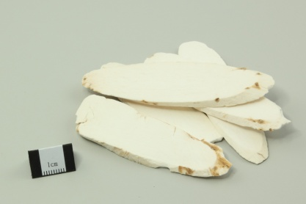  淮山／山药 Huai Shan / Shan Yao  Chinese yam (rhizome)  (PolyU, n.d.-f) | Sweet; neutral | Spleen, Lung, Kidney | Supports Spleen and Stomach; generates fluids and benefits Lung; strengthens Kidney. | Poor appetite and persistent diarrhoea in Spleen deficiency; chronic cough in Lung deficiency; frequent urination in Kidney deficiency.
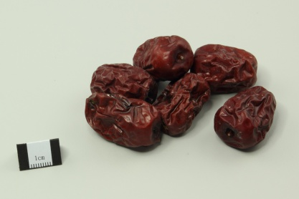  红枣／大枣 Hong Zao / Da Zao  Red dates / jujube (fruit)  (PolyU, n.d.-d) | Sweet; warm | Spleen, Stomach | Tonifies middle Qi; nourishes Blood; calms the spirit. | Poor appetite, tiredness and loose stools in Spleen-deficiency patterns.
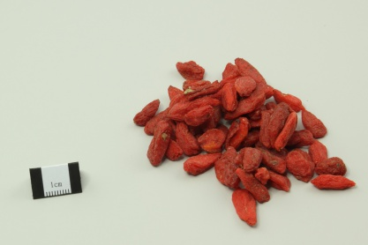  枸杞子 Gou Qi Zi  Goji / wolfberry (fruit)  (PolyU, n.d.-b) | Sweet; neutral | Liver, Kidney | Nourishes Liver and Kidney; replenishes essence; supports vision. | Dizziness, aching lower back and knees, and impaired vision in Liver–Kidney deficiency patterns.
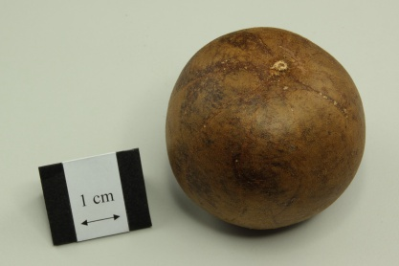  罗汉果 Luo Han Guo  Monk fruit (fruit)  (PolyU, n.d.-j) | Sweet; cool | Lung, Large Intestine | Clears heat; moistens Lung; lubricates the intestines. | Dry cough, sore throat and hoarseness in Lung-heat dryness; constipation from intestinal dryness.
Note. Reference photographs and traditional profiles are adapted from the Hong Kong Polytechnic University database (PolyU); they were not photographed at Tong Keow. Meridian names refer to TCM functional systems. Applications depend on assessed patterns, not a symptom alone.

A2 Eight reported product categories with illustrations
The eight categories follow presentation slide 4. The supplied photograph identifies Nature’s Green Mind Soothe Capsules as an example, while formulas and sales ranks remain unverified. The five-column layout follows Table A1; an ingredient’s profile is not assigned to an unidentified finished product.
Table A2 Illustrated profiles of the eight presentation product categories
Product or category | Nature & Flavour | Meridian | Function | Application
Ginseng tonics  人参／西洋参 | Varies by formula. | Not recorded. | Staff linked use to fatigue, Qi support and immunity. | Age-specific purchases were not measured.
罗汉果  Monk-fruit products  Reference material: monk fruit  (PolyU, n.d.-j) | Reference fruit: sweet and cool. | Reference fruit: Lung and Large Intestine. | Staff associated it with throat comfort and cooling. | Fruit and drink forms were described, with recipes unrecorded.
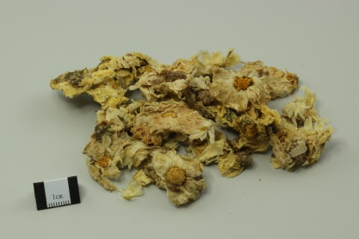  花茶／凉茶  Flower and herbal teas  Reference flower: chrysanthemum  (PolyU, n.d.-e) | Mixture not recorded. | Mixture not recorded. | Staff described everyday wellness uses. | Staff linked simple brewing to younger buyers.
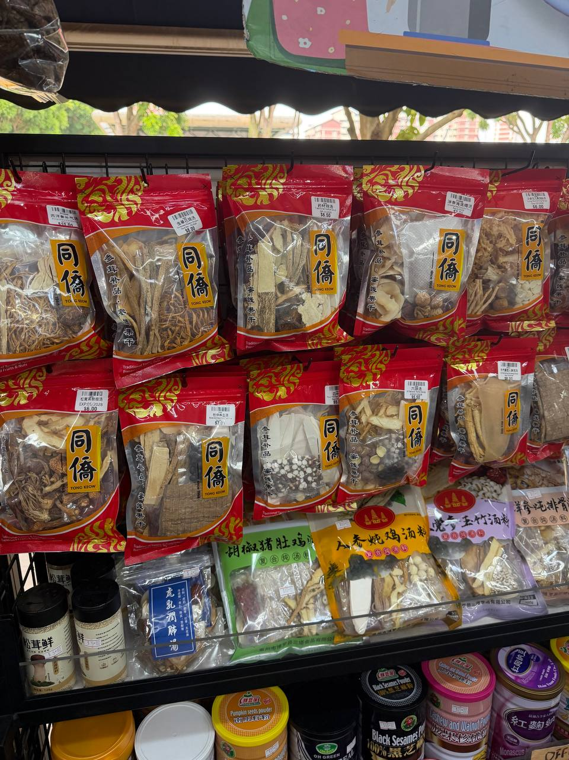  药材汤包  Soup packs  Fieldwork soup display  13 September 2026 | Complete recipe unknown. | Formula not recorded. | Presentation: light nourishment. | Preselected dried packs still require cooking.
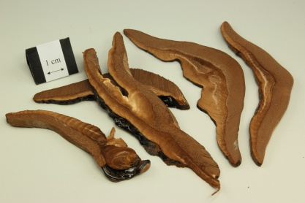  灵芝保健品  Lingzhi supplements  Reference: Lingzhi  (PolyU, n.d.-i) | Supplement formula unknown. | Whole-product affinities unrecorded. | Staff associated supplements with immunity support. | No immune response or clinical outcome was measured.
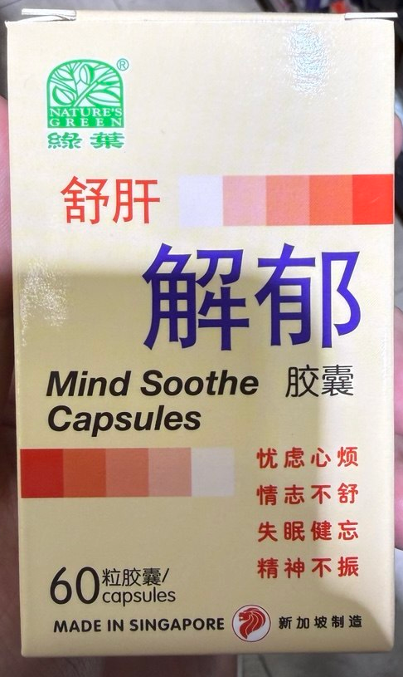  养肝／疏肝解郁  Nature’s Green 绿叶  Mind Soothe Capsules  Supplied photograph | Formula not recorded. | Whole-product affinities unrecorded. | Staff described Liver nourishment and soothing constraint; the box uses “Mind Soothe” language. | Staff linked use to late nights and stress; the photograph identifies an example, without clinical assessment.
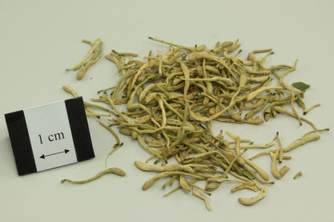  银翘类  Yin Qiao-type remedies  Reference: honeysuckle  (PolyU, n.d.-k) | Exact formula unidentified. | Whole-product affinities unrecorded. | Staff associated this category with cold symptoms. | The retail association has no recorded patient assessment.
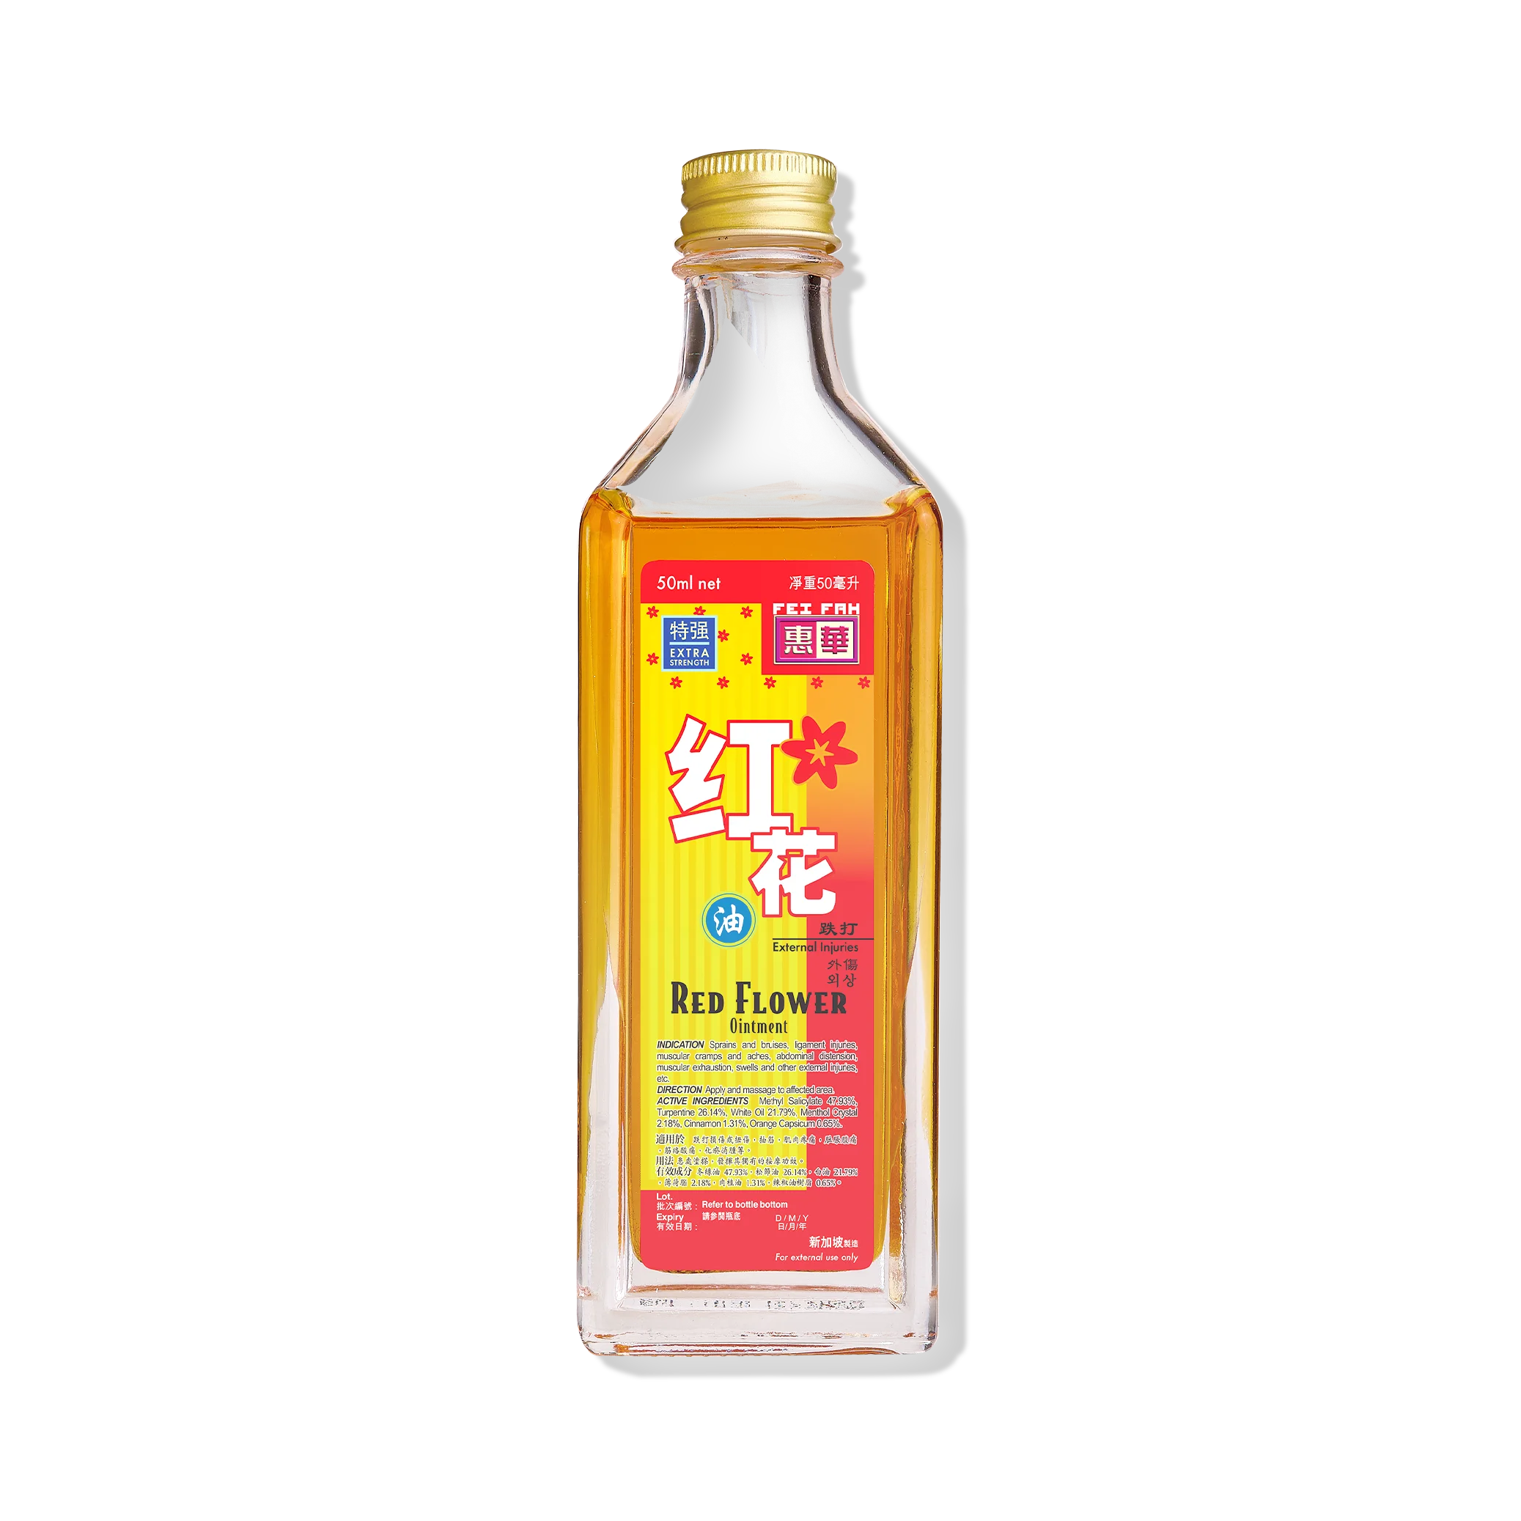  红花油／红油精  Medicated oils  External example  (Fei Fah, n.d.) | Topical formula unidentified. | No meridian assigned. | Staff associated oils with aches and injuries. | Staff described external use, including by older customers.
Note. Uses follow the interview or presentation. The supplied Nature’s Green photograph identifies the illustrated product; other reference illustrations do not verify stock. The front label does not establish its formula, efficacy or clinical suitability.

A3 Five locally linked examples and production status
The staff account names five examples but does not verify five locally grown or manufactured products. Cultivation, manufacture, processing, packing and branding are different claims. The supplementary product photograph identifies a Nature’s Green preparation marked “Made in Singapore”; that label supplements the staff account without independently verifying manufacture.
Table A3 Locally linked examples retained from the presentation
Example | Raw origin and grown in Singapore | Manufacture in Singapore | Processing packaging or brand link
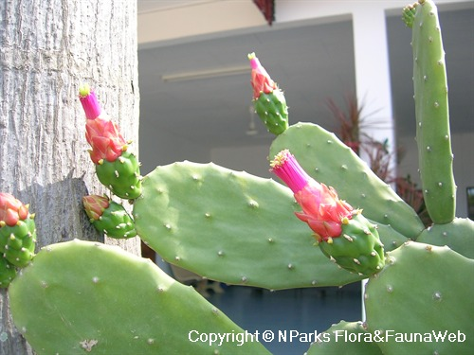  Cactus 仙人掌  (NParks, n.d.-b) | Named as a possible locally grown example; origin of stock unknown | Not established | No specific product or producer identified.
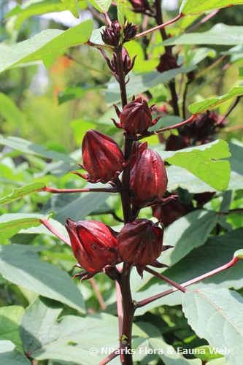  Roselle 洛神花  (NParks, n.d.-a) | Named as a possible locally grown example; origin of stock unknown | Not established | No specific product or producer identified.
Patent medicines  中成药  Nature’s Green example | Imported ingredients discussed generally; item origin unknown | Staff described a Singapore-made preparation; the pictured box also states “Made in Singapore”. | The photograph identifies this example, without independently verifying its factory or supply chain.
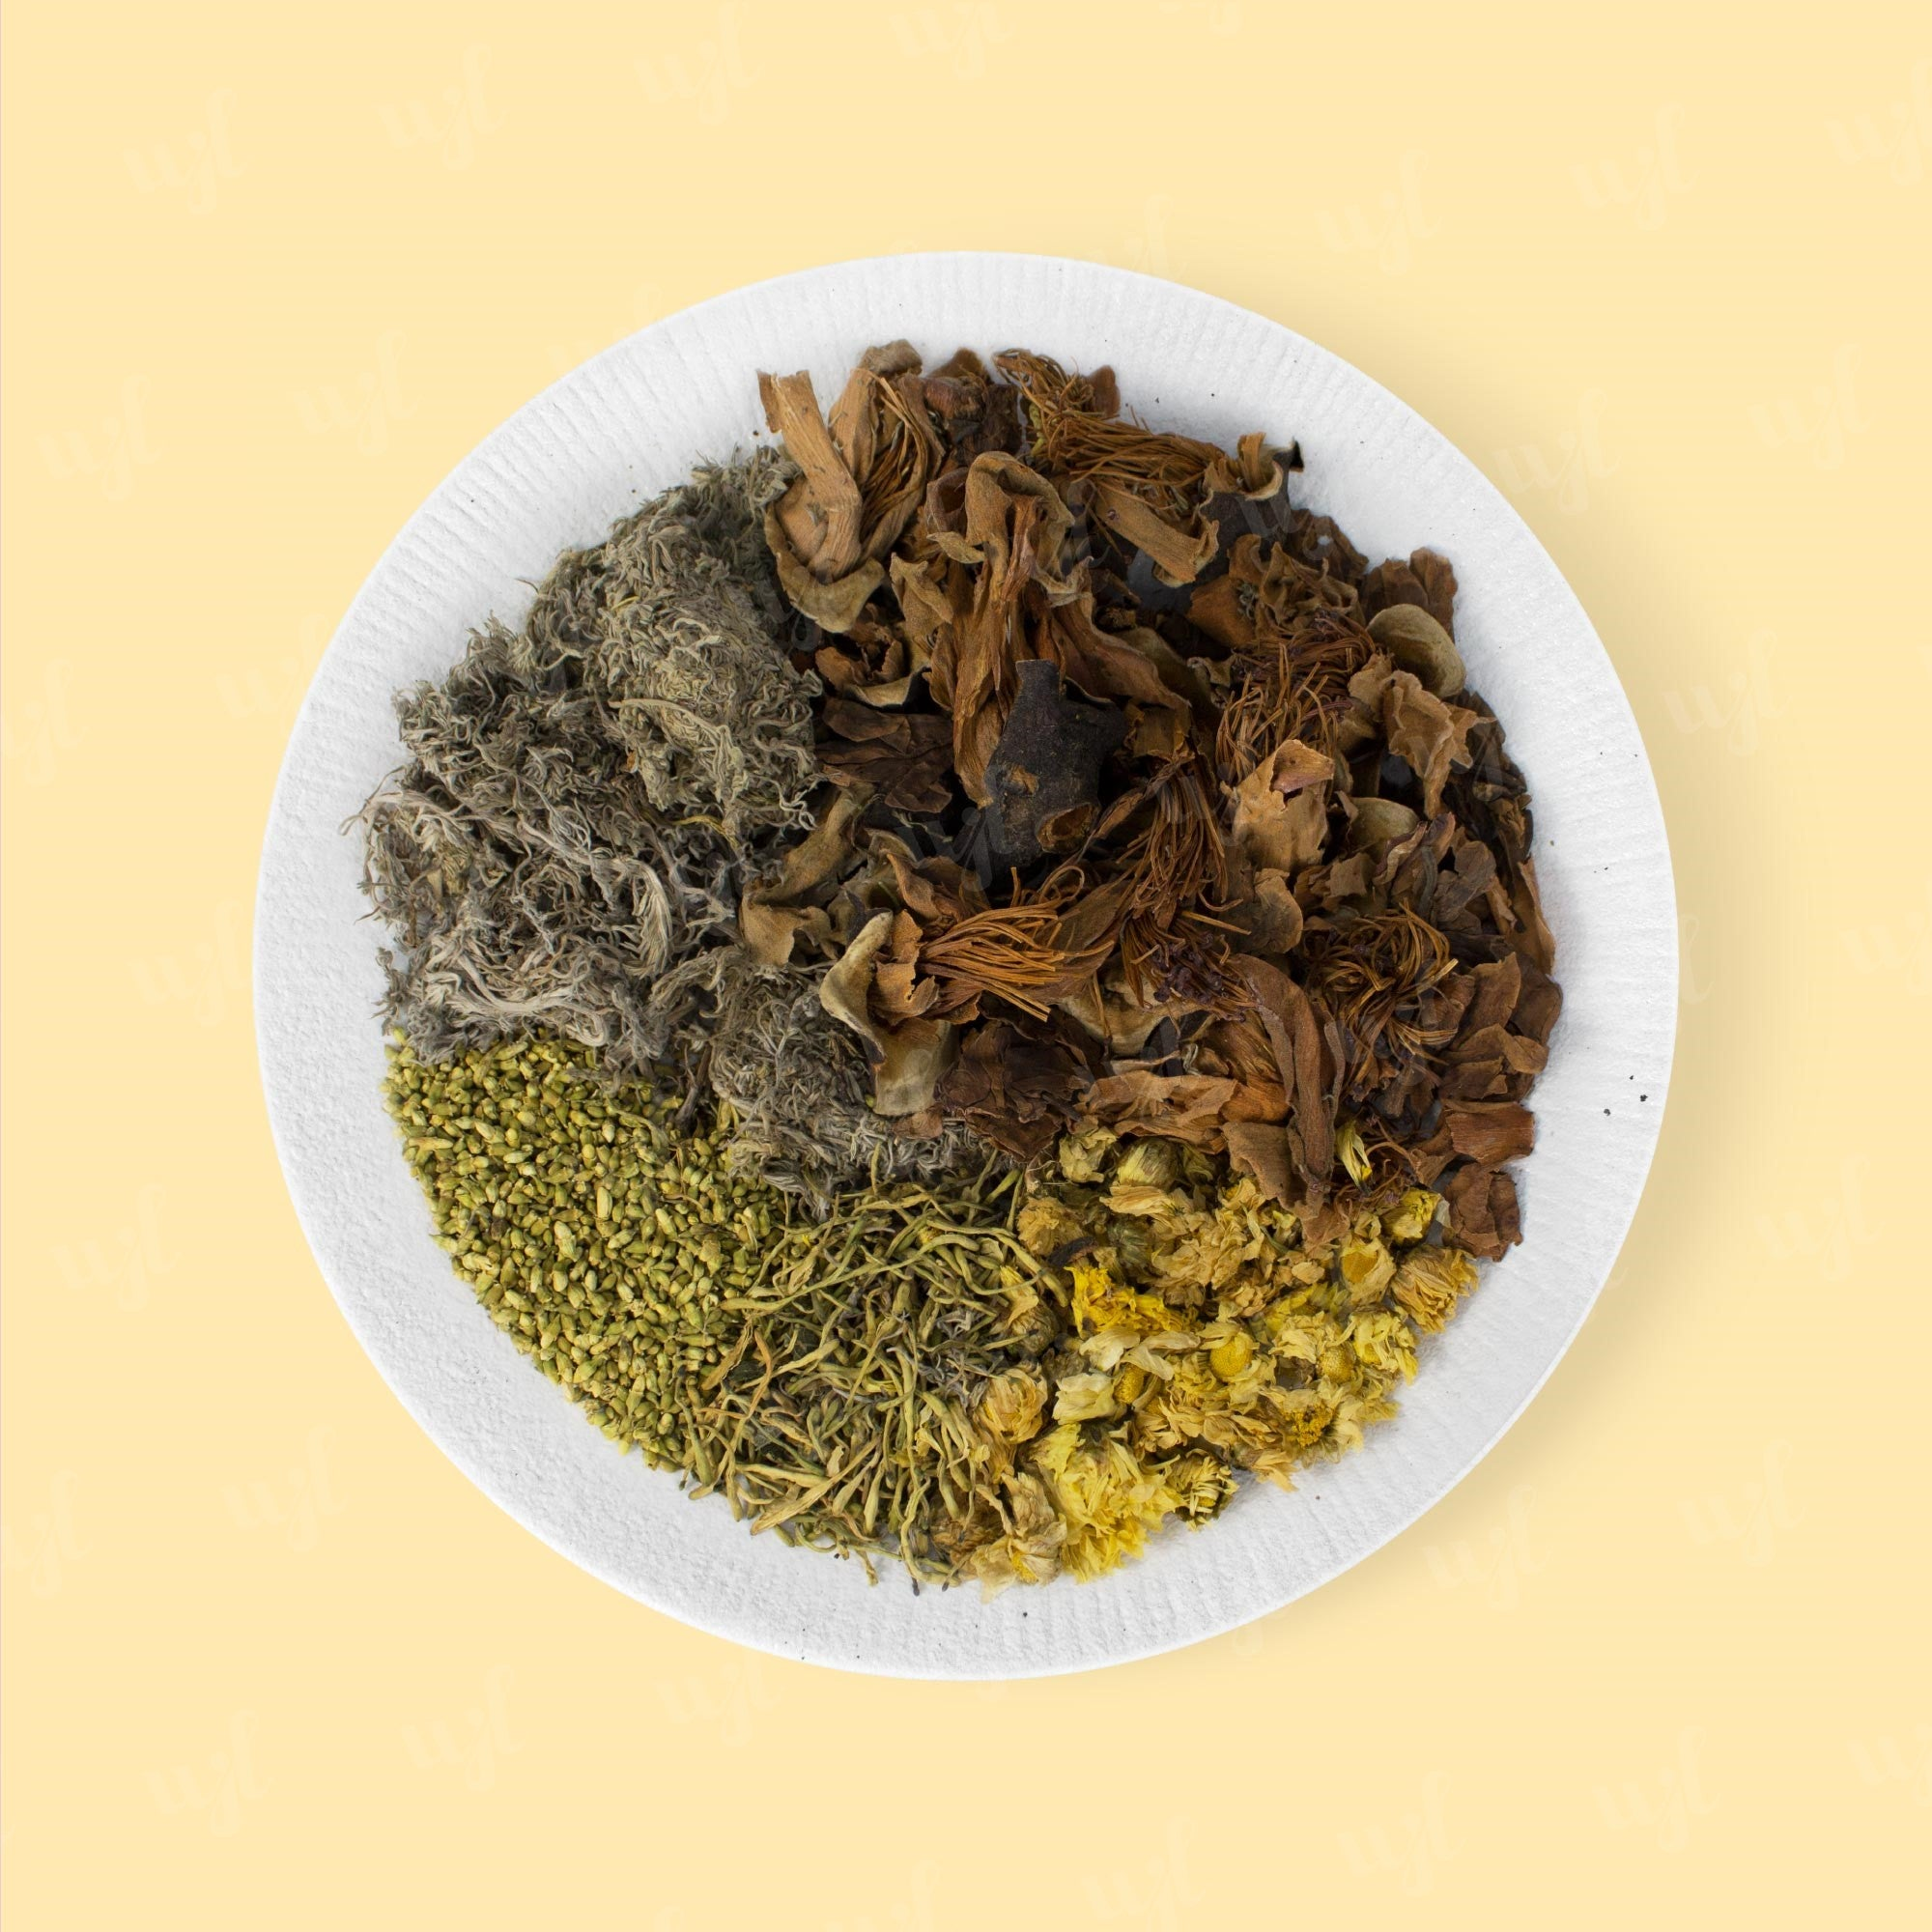  Five Flower Tea  五花茶  (Wing Joo Loong, n.d.) | Not established | Not established | Locally linked in the presentation; item-specific processor, packer and brand unknown.
Monk fruit tea  罗汉果茶  Reference: monk fruit  (PolyU, n.d.-j) | Not established for the tea product | Not established | Locally linked in the presentation; item-specific processor, packer and brand unknown.
Note. NParks photographs show reference plants; the interview did not identify a cactus species or the origin of the stock. The Wing Joo Loong image is an external Five Flower Tea example, and monk fruit illustrates an ingredient. Neither identifies Tong Keow’s tea product. The Nature’s Green photograph shows a label, not independently audited manufacture.

A4 Five soup therapies retained from the presentation
The five labels match slide 6. The staff separately named Dang Shen, Huang Qi, Yu Zhu, Huai Shan, red dates and goji as common soup ingredients, without supplying five complete recipes. These are maintenance and climatic-wellness positions rather than documented clinical recovery cases.
Table A4 Soup labels ingredients and reported purposes
Soup label | Ingredients available from the record | Purpose and main use
Qing Bu Liang 清补凉  Field display context only | Complete recipe not recorded | Light nourishment and climatic wellness; health maintenance in the presentation’s interpretation.
Dang Shen and Huang Qi soup  党参北芪补气汤  Named ingredients only | Dang Shen and Huang Qi are named; complete recipe unknown | Qi support and nourishment; maintenance rather than documented clinical recovery.
Yu Zhu and Huai Shan soup  玉竹淮山润燥汤  Named ingredients only | Yu Zhu and Huai Shan are named; complete recipe unknown | Moistening and nourishment; climatic wellness positioning.
Goji and red date soup  枸杞红枣养生汤  Named ingredients only | Goji and red dates are named; complete recipe unknown | Everyday nourishment and health maintenance.
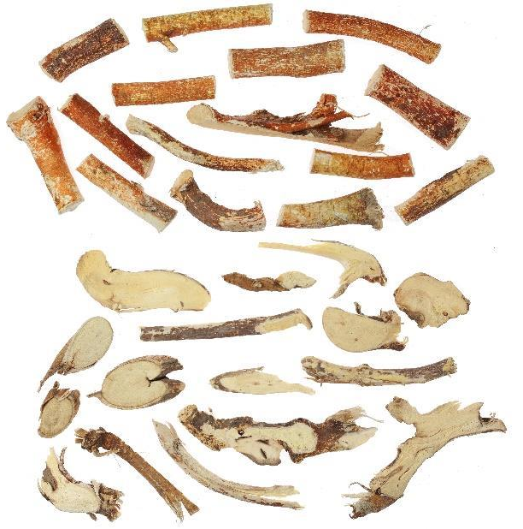  Five Finger Fig soup  五指毛桃健脾汤  Reference root only (DH, n.d.) | Five Finger Fig is named; other ingredients not recorded | Spleen and digestive support in traditional terms; maintenance positioning.
Note. Images show named materials, not complete formulas or finished soups. PolyU supplies Dang Shen, Huang Qi, Yu Zhu, Huai Shan, goji and red dates (n.d.-m, n.d.-l, n.d.-g, n.d.-f, n.d.-b, n.d.-d); Hong Kong’s Department of Health (DH, n.d.) supplies Five Finger Fig root. The Qing Bu Liang image shows field display context only.

A5 Three comparatively lower-demand examples with illustrations
This table preserves former Section 3.5 and presentation slide 8. It contains one named herb and two broad categories. Neither a verified bottom-three rank nor three distinct medicinal species was recorded. Broad categories cannot be given a single nature or meridian profile.
Table A5 Illustrated profiles of the lower-demand examples
Product or category | Nature & Flavour | Meridian | Function | Application
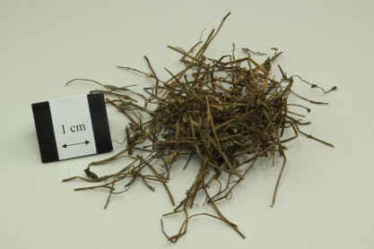  半枝莲 Ban Zhi Lian  Barbated skullcup herb  Reference material  (PolyU, n.d.-c) | Sweet, bitter and cold. | Liver, Lung and Kidney. | Reference: clears heat and toxins, resolves stasis and promotes urination. | Reference uses include sores, throat swelling and oedema.
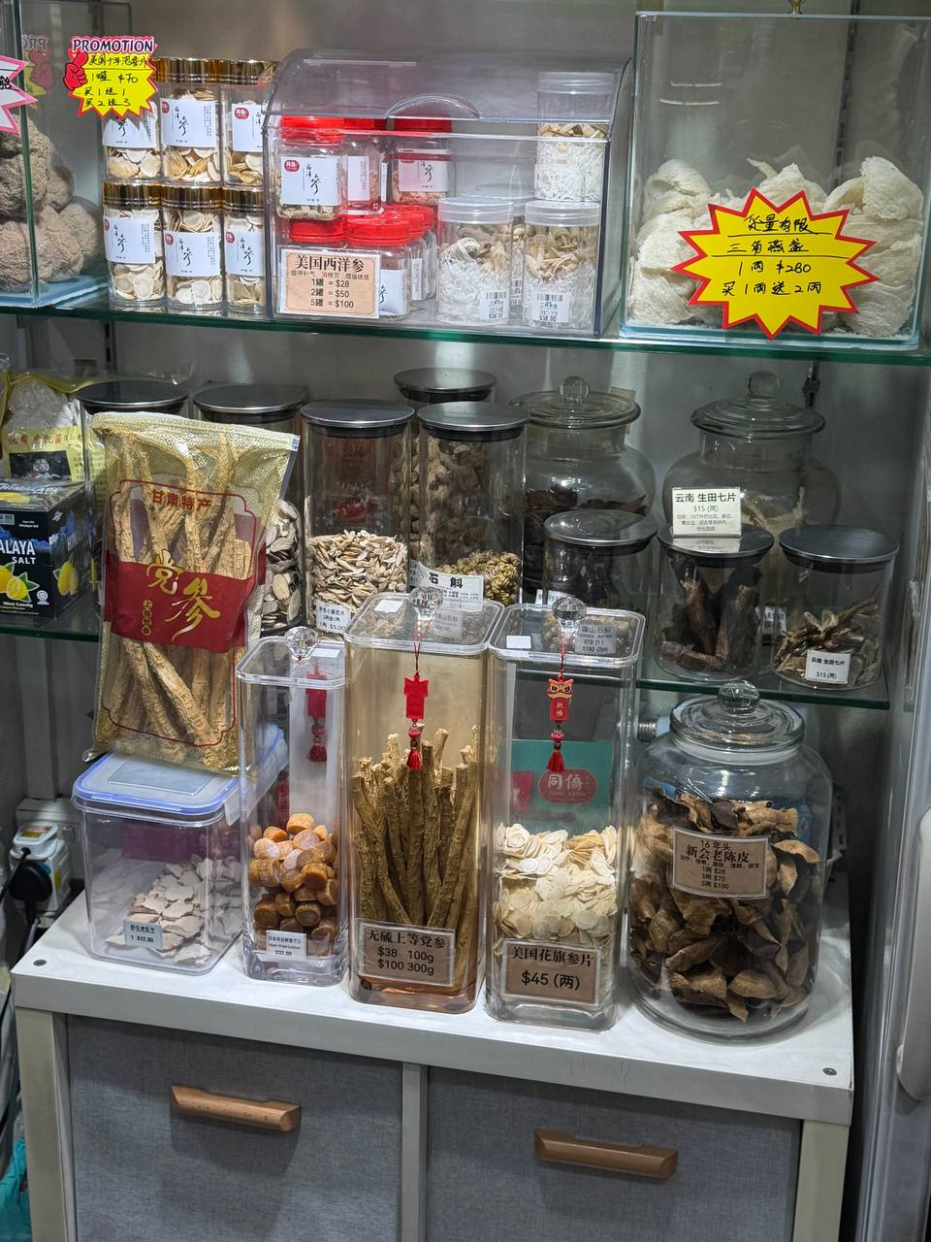  Specialist herbs  Requiring combinations | Varies by formula. | Varies by formula. | No combination was identified. | Staff described a need for preparation and guidance.
大补方  Strong tonic formulas  Tonic material illustration only  (PolyU, n.d.-h) | Formula not recorded. | Formula not recorded. | Presentation: intensive replenishment 大补. | The presentation associated lower appeal with suitability and climate.
Note. Ban Zhi Lian properties are PolyU reference information. The specialist-herb photograph shows the field cabinet only; no second low-demand herb or combination was identified. The ginseng illustration does not identify a strong-tonic formula. Lower demand is staff-reported, not a verified ranking.

A6 Physician evidence and separate retail associations
Physician presence was not clearly confirmed. Accordingly, eight physician prescriptions and eight physician-treated symptoms remain not established. The six associations below are staff-reported retail pairings retained from slide 9. Patient examination, exact formulations, doses and treatment durations were not recorded.
Table A6 Retail symptom associations without confirmed clinical prescriptions
Complaint or wellness concern | Associated retail product | Interpretive qualification
Colds | Yin Qiao type remedies | A broad complaint does not establish the pattern for which a formulation is suitable.
Diarrhoea | Huoxiang Zhengqi type remedies | Staff association; no individual cause or pattern assessed.
Fatigue or Qi deficiency language | Ginseng or Dang Shen | Fatigue alone does not demonstrate Qi deficiency.
Perceived lower immunity | Lingzhi or supplements | Wellness claim rather than measured immune dysfunction.
Late nights stress and long work hours | Liver care or mood support products | Retail lifestyle framing; no liver disease or mental health diagnosis established.
Aches or injuries | Medicated oils | Reported topical retail use; no clinical injury assessment recorded.

Appendix A7 Survey coverage and evidential status
Table A7 Appendix survey coverage and evidence limits
Survey item | Record retained | Location | Evidence limit
A | Eight herb entries; nine reference profiles | A1; Section 3.1 | No verified twelve-month sales ranking.
B | Eight product categories | A2; Section 4 | Exact products and comparative sales unknown.
C | Five locally linked examples | A3; Section 5.1 | Cultivation and manufacture unverified by item.
D | Five soup labels | A4; Section 3.2 | Complete recipes and all pack identities unconfirmed.
E | One named herb and two categories | A5; Section 4.3 | No verified bottom-three ranking.
F | Physician prescriptions not established | A6; Section 7 | Physician role not confirmed; no clinical cases recorded.
G | Six separate retail associations | A6; Section 6.1 | Not eight physician-treated symptoms or case records.

References
Accounting and Corporate Regulatory Authority. (n.d.). ACRA information on corporate entities (T) [Data set]. Data.gov.sg. Retrieved October 4, 2026, from https://data.gov.sg/datasets/d_72f37e5c5d192951ddc5513c2b134482/view
Amacha. (n.d.). Amacha herbal milk tea [Menu and brand website]. Retrieved October 4, 2026, from https://www.amacha.sg/
Angelynn T. (2026, January 5). This S’pore biz is turning TCM into milk tea—8 mths in, it now has 3 outlets & sold 150K+ cups. Vulcan Post. https://vulcanpost.com/907853/amacha-herbal-milk-tea/
Chin, S. F. (2024, May 26). Innovation amid tradition: How Chinatown merchants move with the times. The Straits Times. https://www.straitstimes.com/singapore/innovation-amid-tradition-how-chinatown-merchants-move-with-the-times
Chua, V., Feng, C.-C., & Ho, E. L.-E. (2025). Ageing in networks: Living alone but connected. Ageing & Society. Advance online publication. https://doi.org/10.1017/S0144686X25100329
Department of Health, Hong Kong. (n.d.). 五指毛桃與斷腸草 [Five Finger Fig root and Gelsemium]. Chinese Medicine Regulatory Office. https://www.cmro.gov.hk/files/gcmti/research/mmi/ech_search/041_RF_vs_HGE_tc.pdf
Eu Yan Sang. (n.d.). Shop halal products. Retrieved October 4, 2026, from https://www.euyansang.com.sg/en/halal-2/
Fei Fah. (n.d.). Red flower ointment 50 ml [Product photograph]. Retrieved October 4, 2026, from https://feifah.com/zh/products/red-flower-ointment-50ml
Health Sciences Authority. (2025, January). Guidelines on Chinese Proprietary Medicines product listing. https://file.go.gov.sg/hsa-cpm-listing-fsc-guidelines.pdf
Health Sciences Authority. (2026a, May 4). Health supplement claims. https://www.hsa.gov.sg/health-supplements/claims/
Health Sciences Authority. (2026b, April 6). How Chinese Proprietary Medicines are regulated by HSA. https://www.hsa.gov.sg/announcements/how-chinese-proprietary-medicines-are-regulated-by-hsa/
Health Sciences Authority. (2026c, March 13). Overview of dealer’s licences for Chinese Proprietary Medicines. https://www.hsa.gov.sg/chinese-proprietary-medicines/manufacturing-import-wholesale/dealers-licence/overview/
Health Sciences Authority. (2026d, May 29). Safety precautions when buying Chinese medicinal pills and capsules. https://www.hsa.gov.sg/announcements/safety-precautions-when-buying-chinese-medicinal-pills-and-capsules/
Healthcare.com.sg. (n.d.). Tong Keow Medical Hall (Hougang Central). Retrieved October 4, 2026, from https://www.healthcare.com.sg/item/tong-keow-medical-hall-hougang-central/
The Hong Kong Polytechnic University. (n.d.-a). American ginseng. Chinese Herbal Medicine Database. https://herbaltcm.sn.polyu.edu.hk/herbal/american-ginseng
The Hong Kong Polytechnic University. (n.d.-b). Barbary wolfberry fruit. Chinese Herbal Medicine Database. https://herbaltcm.sn.polyu.edu.hk/herbal/barbary-wolfberry-fruit
The Hong Kong Polytechnic University. (n.d.-c). Barbated skullcup herb. Chinese Herbal Medicine Database. https://herbaltcm.sn.polyu.edu.hk/herbal/barbated-skullcup-herb
The Hong Kong Polytechnic University. (n.d.-d). Chinese date. Chinese Herbal Medicine Database. https://herbaltcm.sn.polyu.edu.hk/herbal/chinese-date
The Hong Kong Polytechnic University. (n.d.-e). Chrysanthemum flower. Chinese Herbal Medicine Database. https://herbaltcm.sn.polyu.edu.hk/herbal/chrysanthemum-flower
The Hong Kong Polytechnic University. (n.d.-f). Common yam rhizome. Chinese Herbal Medicine Database. https://herbaltcm.sn.polyu.edu.hk/herbal/common-yam-rhizome
The Hong Kong Polytechnic University. (n.d.-g). Fragrant solomonseal rhizome. Chinese Herbal Medicine Database. https://herbaltcm.sn.polyu.edu.hk/herbal/fragrant-solomonseal-rhizome
The Hong Kong Polytechnic University. (n.d.-h). Ginseng. Chinese Herbal Medicine Database. https://herbaltcm.sn.polyu.edu.hk/herbal/ginseng
The Hong Kong Polytechnic University. (n.d.-i). Glossy Ganoderma. Chinese Herbal Medicine Database. https://herbaltcm.sn.polyu.edu.hk/herbal/glossy-ganoderma
The Hong Kong Polytechnic University. (n.d.-j). Grosvenor momordica fruit. Chinese Herbal Medicine Database. https://herbaltcm.sn.polyu.edu.hk/herbal/grosvenor-momordica-fruit
The Hong Kong Polytechnic University. (n.d.-k). Japanese honeysuckle flower. Chinese Herbal Medicine Database. https://herbaltcm.sn.polyu.edu.hk/herbal/japanese-honeysuckle-flower
The Hong Kong Polytechnic University. (n.d.-l). Milkvetch root. Chinese Herbal Medicine Database. https://herbaltcm.sn.polyu.edu.hk/herbal/milkvetch-root
The Hong Kong Polytechnic University. (n.d.-m). Tangshen. Chinese Herbal Medicine Database. https://herbaltcm.sn.polyu.edu.hk/herbal/tangshen
Housing & Development Board. (2024). Key statistics: HDB annual report 2023/2024. https://www.hdb.gov.sg/hdb-pulse/reports/annual-reports-and-financial-statements
Lim, M. K., Sadarangani, P., Chan, H. L., & Heng, J. Y. (2005). Complementary and alternative medicine use in multiracial Singapore. Complementary Therapies in Medicine, 13(1), 16–24. https://doi.org/10.1016/j.ctim.2004.11.002
Liu, Y., Yang, Q., & Hu, Y. (2026). Translation variations under legal constraints in the packaging information of traditional Chinese herbal medicine sold in Malaysia. International Journal of Multilingualism, 23(1), 973–1000. https://doi.org/10.1080/14790718.2025.2537184
Meteorological Service Singapore. (n.d.). Climate of Singapore. https://www.weather.gov.sg/climate-climate-of-singapore
Ministry of Health. (2025, July 6). Speech by Mr Ong Ye Kung, Minister for Health, at the forum on the use of evidence-based Traditional Chinese Medicine in Western medicine practice. https://www.moh.gov.sg/newsroom/speech-by-mr-ong-ye-kung--minister-for-health--at-the-forum-on-the-use-of-evidence-based-traditional-chinese-medicine-in-western-medicine-practice/
Ministry of Health. (2026, February 10). About. https://hpp.moh.gov.sg/tcm-practitioners/about/
Ministry of Manpower. (2026, February 3). Written answer to PQ on moderating working hours. https://www.mom.gov.sg/newsroom/parliament-questions-and-replies/2026/0203-written-answer-to-pq-on-moderating-working-hours
Nanyang Polytechnic. (n.d.). From tradition to trend: NYP’s collaborative journey with Heng Foh Tong in revolutionising herbal drinks. https://www.nyp.edu.sg/industry/projects/revolutionise-herbal-drinks-heng-foh-tong
National Heritage Board. (n.d.). Tou Mu Kung. Roots. https://www.roots.gov.sg/places/places-landing/Places/national-monuments/tou-mu-kung
National Parks Board. (n.d.-a). Hibiscus sabdariffa L. Flora & Fauna Web. https://www.nparks.gov.sg/florafaunaweb/flora/2/0/2096
National Parks Board. (n.d.-b). Opuntia cochenillifera. Flora & Fauna Web. https://www.nparks.gov.sg/florafaunaweb/flora/2/2/2281
Singapore Department of Statistics. (n.d.). Coverage of Singapore retail trade industry 2021 [SSIC 2020 codes]. https://www.singstat.gov.sg/-/media/files/find_data/industry/coverage-retail.pdf
Singapore Department of Statistics. (2024). Resident population by planning area/subzone, age group and type of dwelling, June 2024 [Data set]. https://www.singstat.gov.sg/find-data/explore-data-themes/population/geographic-distribution/latest-news-data
Singapore Department of Statistics. (2025). Resident population by planning area/subzone, age group and type of dwelling, June 2025 [Data set]. https://www.singstat.gov.sg/find-data/explore-data-themes/population/geographic-distribution/latest-news-data
Unschuld, P. U. (2018). Traditional Chinese medicine: Heritage and adaptation (B. Andrews, Trans.). Columbia University Press. https://cup.columbia.edu/book/traditional-chinese-medicine/9780231175012/
Unschuld, P. U., & Tessenow, H. (2011). Huang Di nei jing su wen: An annotated translation of Huang Di’s Inner Classic—Basic Questions (Vol. 1). University of California Press.
Wing Joo Loong. (n.d.). Lung soothing summer tea. https://www.wjl.com.sg/products/wing-joo-loong-lung-soothing-summer-tea
World Health Organization. (2022). WHO international standard terminologies on traditional Chinese medicine. https://www.who.int/publications/i/item/9789240042322
Yang, Y. (2022). A brief history of Chinese medicine in Singapore. In V. Lo & M. Stanley-Baker (Eds.), Routledge handbook of Chinese medicine (pp. 524–536). Routledge. https://doi.org/10.4324/9780203740262-42

Appendix B Fieldwork photographs
Figure 1
Soup promotion in the neighbourhood retail setting
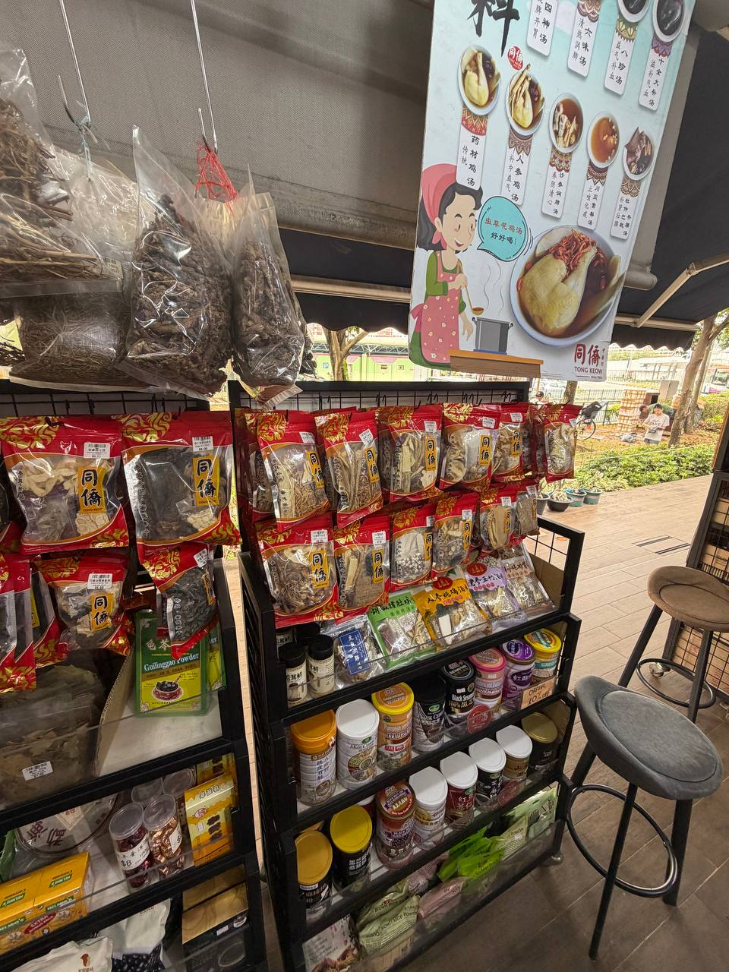
Note. The frontage shows branded soup packs and a family cooking image; it does not establish recipes or a sales ranking. Photograph by the group, Tong Keow Healthcare, 13 September 2026.

Figure 2
Preselected dried soup ingredients in branded packs
Note. The display shows preselected dried soup ingredients requiring preparation; it does not confirm all five soup labels or local manufacture. Photograph by the group, Tong Keow Healthcare, 13 September 2026.

Figure 3
Herb labels and retail quality claims
Note. Labels distinguish American ginseng and claim sulphur-free Dang Shen; they do not verify authenticity, production methods or safety. Photograph by the group, Tong Keow Healthcare, 13 September 2026.

